1. Welcome To This Course!

2. What Is Testing?

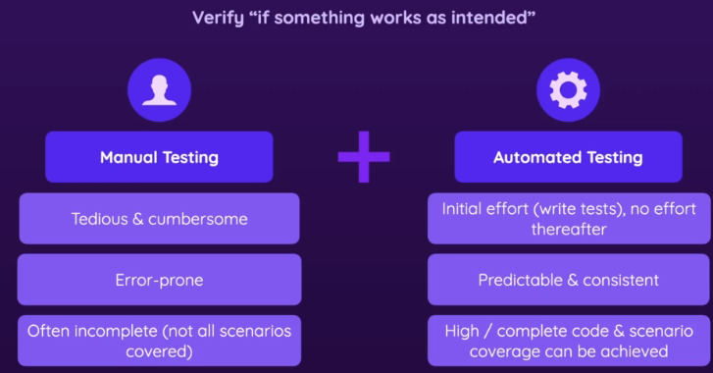

3. Unit Testing: What & Why?

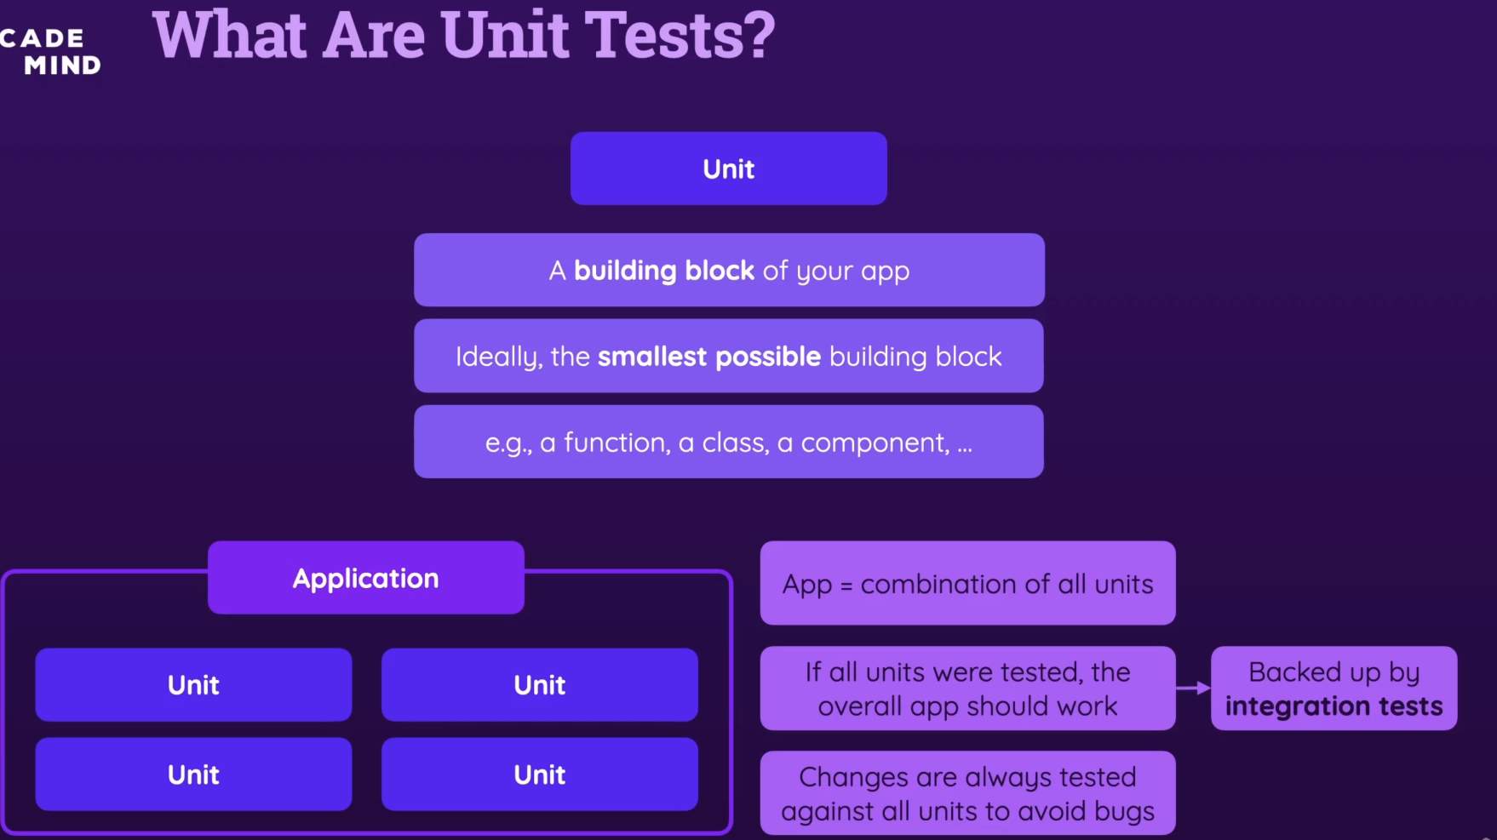

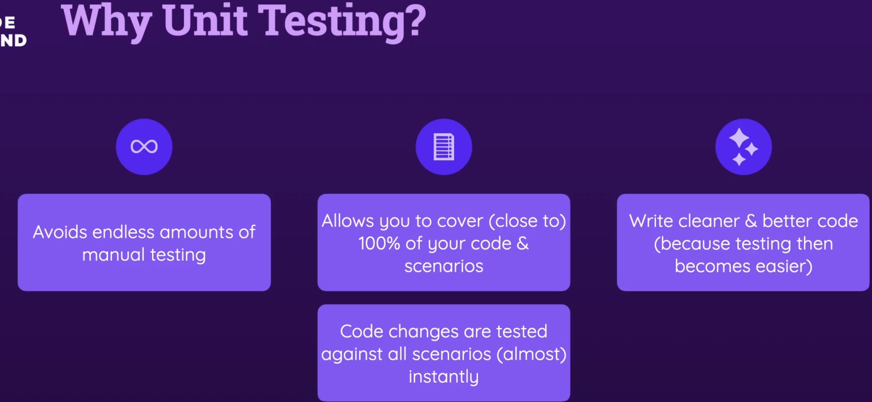

4. Unit vs Integration vs E2E Tests

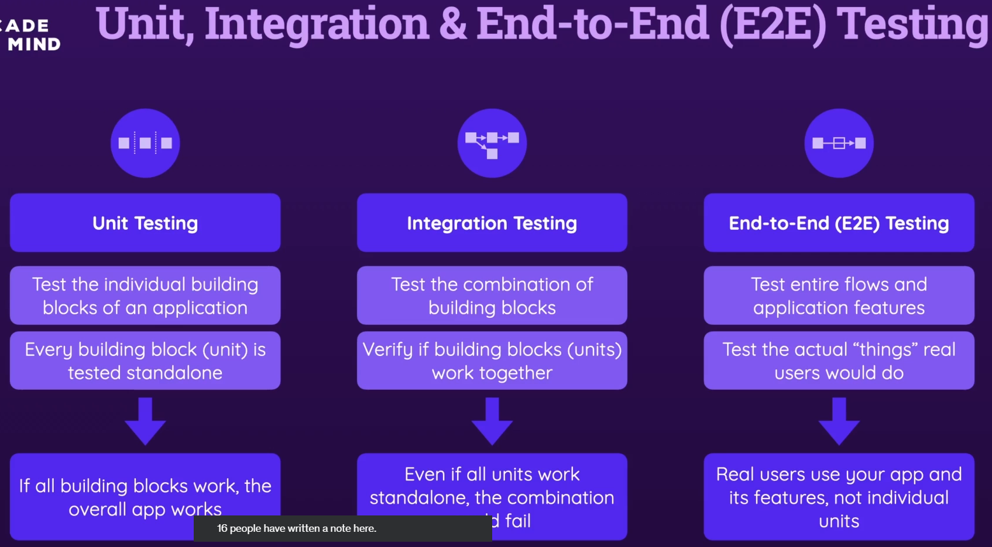

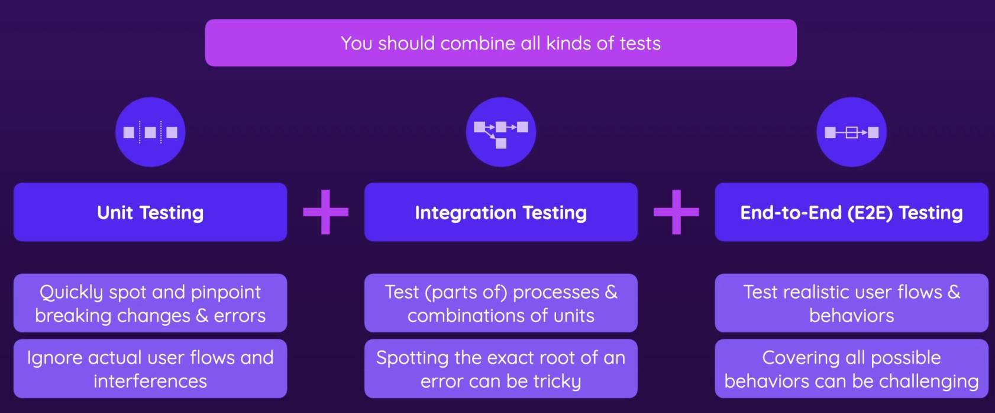

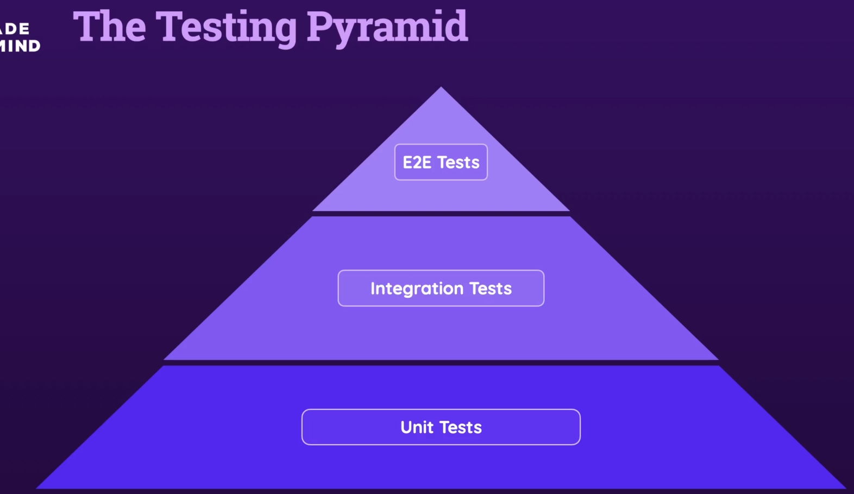

5. A Quick Note About Test-Driven Development (TDD)

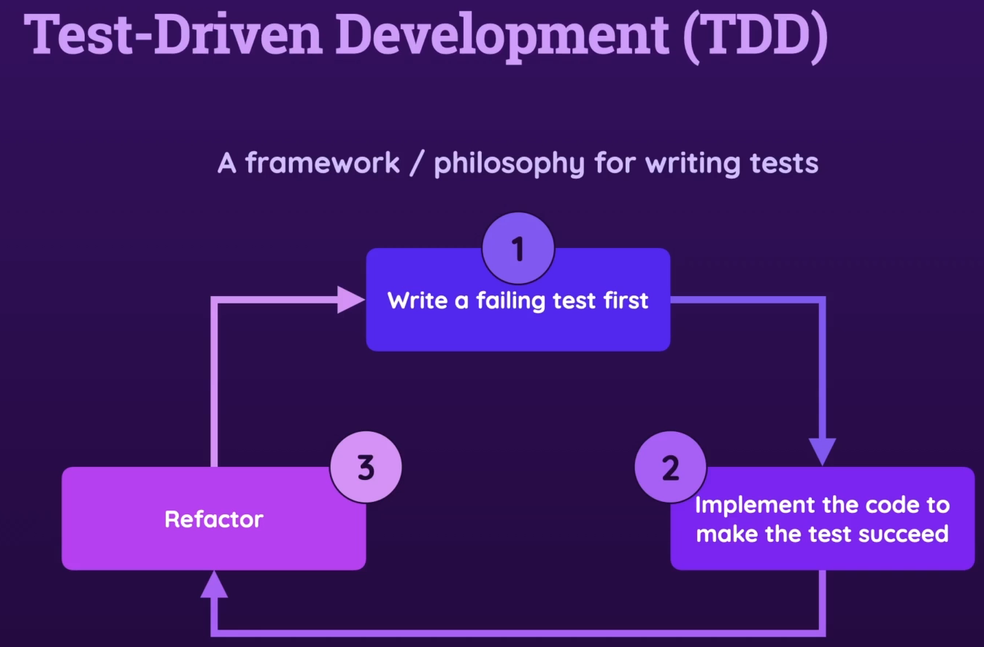

6. About This Course

7. Join Our Learning Community

8. Course Resources & Project Snapshots

9. Course Setup

Section 2: Setup & Testing Software

10. Module Introduction

11. Which Tools Are Needed For Testing?

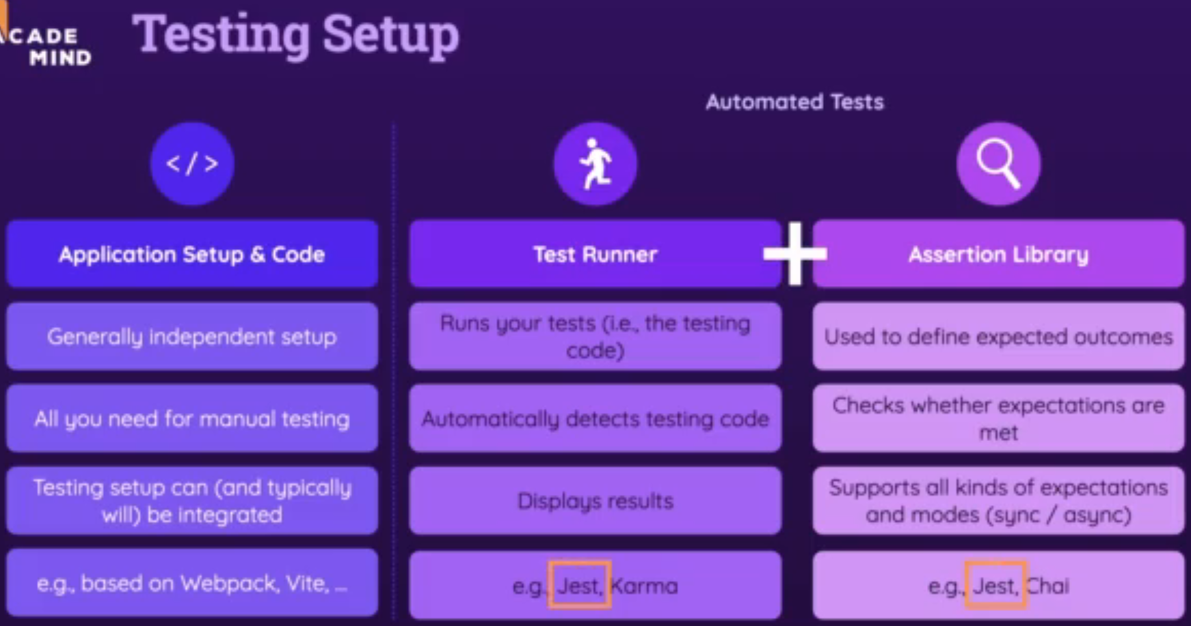

12. Jest & Vitest

13. Installing Vitest

14. Course Project Setup

Section 3: Testing Basics

15. Module Introduction

16. Basic Test File & Project Setup

Insource testing by vitest 🡪 writing tests in the same file

17. Writing a First Test

import { test, it, expect } from 'vitest';

math.test.js

**import { test, it, expect } from 'vitest';**

**import { add } from './math';**

**// test = it**

**it('should sum all number values in an array', () => {**

**//arrange phase**

**const numbers = [1, 2, 3]**

**const expectedResult = numbers.reduce((prev, cur) => prev + cur, 0)**

**//act phase**

**const result = add(numbers);**

**// Assert phase**

**expect(result).toBe(expectedResult);**

**});**

18. Running Tests

19. Why Are We Testing?

20. The AAA Pattern - Arrange, Act, Assert

21. Keep Your Tests Simple!

22. Defining Behaviors & Fixing Errors In Your Code

23. Demo: Writing More Tests

24. Testing For Errors

25. Demo: Adding More Tests

26. Testing For Thrown Errors & Error Messages

27. Exercise: Problem

28. Exercise: Solution

29. Tests With Multiple Assertions (Multiple Expectations)

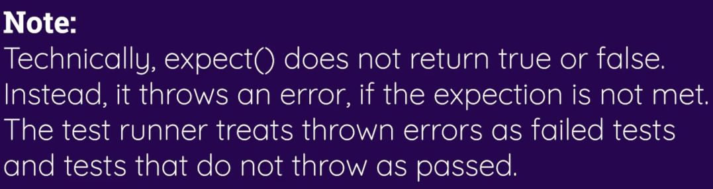

30. More Practice!

31. Introducing Test Suites

32. Adding Tests To Frontend & Backend Projects

33. Module Summary

Section 4: Writing Good Tests

34. Module Introduction

35. What To Test & Not To Test

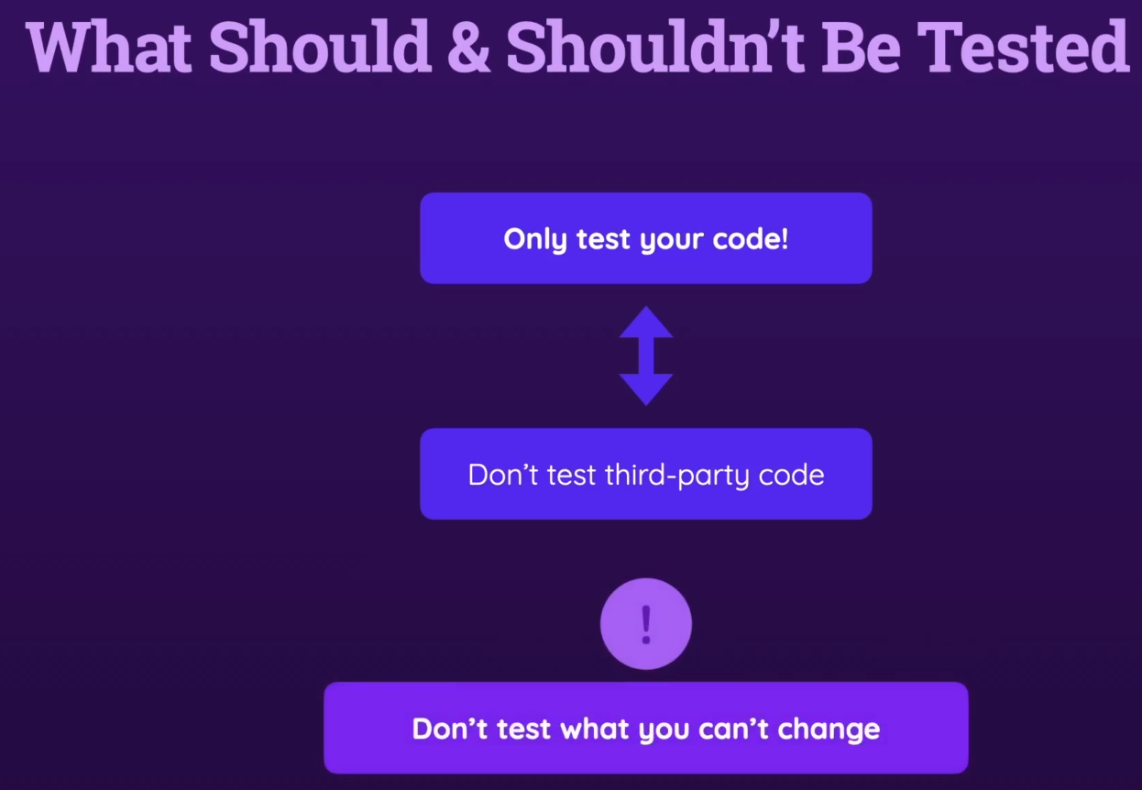

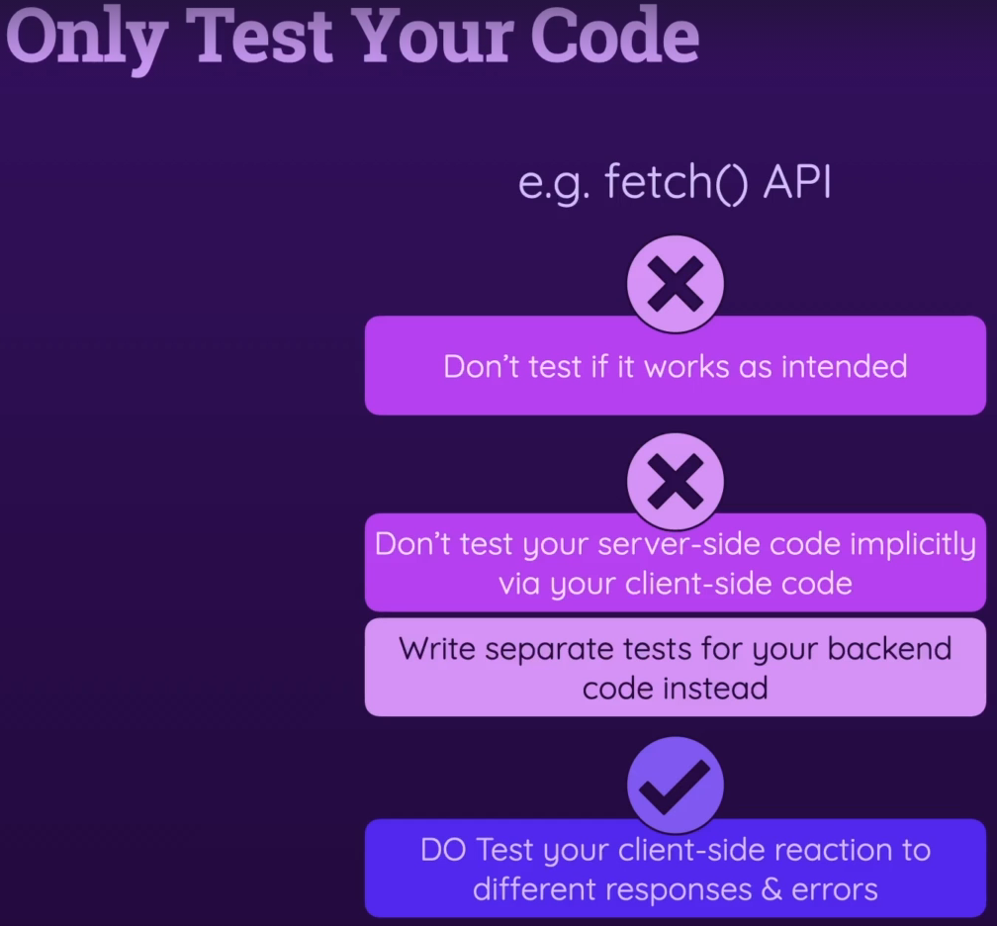

36. Writing Good Tests - An Overview & Summary

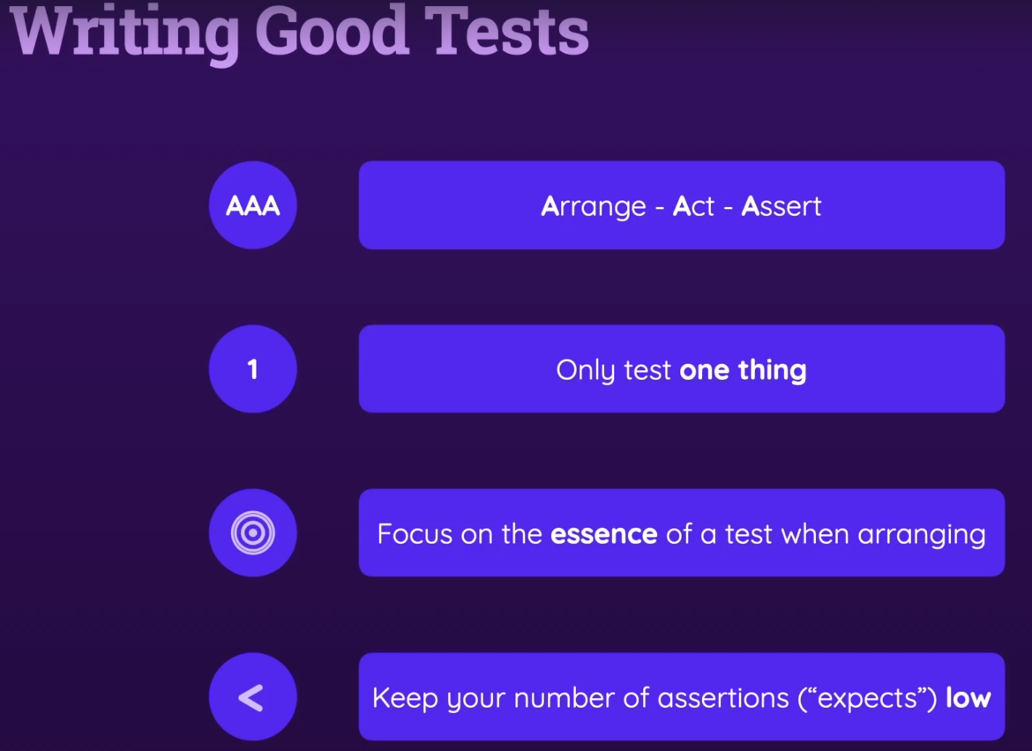

37. Only Test "One Thing"

38. Splitting Functions For Easier Testing & Better Code

39. Refactoring Code

40. Formulating Different Expectations

41. A Word About Code Coverage

42. Module Summary

Section 5: Integration Tests

43. Module Introduction

44. Introducing Integration Tests

45. Writing an Integration Test & Reasoning

46. Testing For Errors

47. Integration vs Unit Tests: Finding the Right Balance

Section 6: Advanced Testing Concepts

48. Module Introduction

49. toBe() vs toEqual()

toEqual makes deep comparison

50. The Problem With Asynchronous Code

51. Testing Asynchronous Code With Callbacks

52. Testing Asynchronous Code With Promises & async / await

53. Returning Promises In Tests

54. Getting Started with "Testing Hooks"

55. Why Hooks?

56. Using Testing Hooks (beforeEach, beforeAll, afterEach, afterAll)

57. Concurrent Tests

58. Concurrency & Default Behavior

59. Module Summary

Section 7: Mocking & Spies: Dealing with Side Effects

60. Module Introduction

61. The Starting Project

62. The Problem With Side Effects & Tests

63. Introducing Spies & Mocks

64. Working with Spies

65. Getting Started with Mocks & Automocking

66. Note on Mocking

67. Notes on Spies

68. Custom Mocking Logic

69. Managing Custom Mock Implementations Globally (__mocks__ Folder)

70. More Mocking Functionalities

71. Module Summary

Section 8: More on Mocking & Diving Deeper

72. Module Introduction

73. The Starting Project

74. Refresher: Practicing Basic Tests (1)

75. Refresher: Practicing Basic Tests (2)

76. Reasons to Mock

77. Mocking Global Values & Functions

78. Mocking Frontend Libraries

79. Test-specific Mocking Logic

80. Mocking In Selected Places

81. Using Local Mock Values

82. Module Summary

Section 9: Testing & The DOM (Frontend JavaScript Testing)

83. Module Introduction

1min

* Lecture incomplete. Progress cannot be changed for this item.

84. Understanding the Problem

4min

Resources

* Lecture incomplete. Progress cannot be changed for this item.

85. Working with Different Testing Environments

4min

* Lecture incomplete. Progress cannot be changed for this item.

86. Setting up a Virtual HTML Page

5min

* Lecture incomplete. Progress cannot be changed for this item.

87. Testing DOM Functionalities

3min

* Lecture incomplete. Progress cannot be changed for this item.

88. DOM Tests & Cleanup Work

3min

* Lecture incomplete. Progress cannot be changed for this item.

89. Finishing Example

2min

* Lecture incomplete. Progress cannot be changed for this item.

90. A Brief Look at the "Testing Library" Package

2min

* Lecture incomplete. Progress cannot be changed for this item.

91. Module Summary

